**Project Design Phase**

**Problem – Solution Fit Template**

|  |  |
| --- | --- |
| Date | 15 February 2025 |
| Team ID | LTVIP2025TMID45799 |
| Project Name | TrafficTelligence: Advanced Traffic Volume Estimation with Machine Learning |
| Maximum Marks | 2 Marks |

## ****Problem – Solution Fit Canvas****

### ****1. Target Group (Users/Beneficiaries)****

* Urban commuters
* City traffic departments
* Smart city authorities
* Transportation planners

### ****2. Problem Description (Customer Pains / Challenges)****

* Long traffic jams during peak hours and bad weather
* No reliable real-time prediction tool for traffic volume
* Traditional systems are reactive, not predictive
* Manual planning of signal timings and road utilization

### ****3. Current Alternatives / Workarounds****

* Google Maps, which gives approximate travel time but not exact traffic volume
* Government dashboards using fixed-sensor data
* Static traffic signal schedules

### ****4. Behavior Triggers****

* Frustration due to traffic delays
* Search for alternate routes via apps
* Complaints about poor traffic management
* Increased demand for real-time civic apps

### ****5. The Solution Offered****

* A machine learning model that predicts traffic volume using:
  + Weather conditions
  + Date & time (hour, day, month)
  + Historical traffic patterns
* A simple web UI that allows users to input conditions and get predictions
* Visual charts for trend analysis
* Logs and performance metrics displayed

### ****6. Benefits / Value Delivered****

* Improved planning of traffic signal timings
* Help commuters plan their journey in advance
* Integrate with smart city dashboards
* Reduce traffic congestion and improve mobility
* Data-driven decisions for city infrastructure

### ****7. Adoption Channels****

* Integrated into municipal websites or apps
* Public display systems on highways
* APIs offered to traffic management platforms
* Citizen awareness campaigns

**Template:**

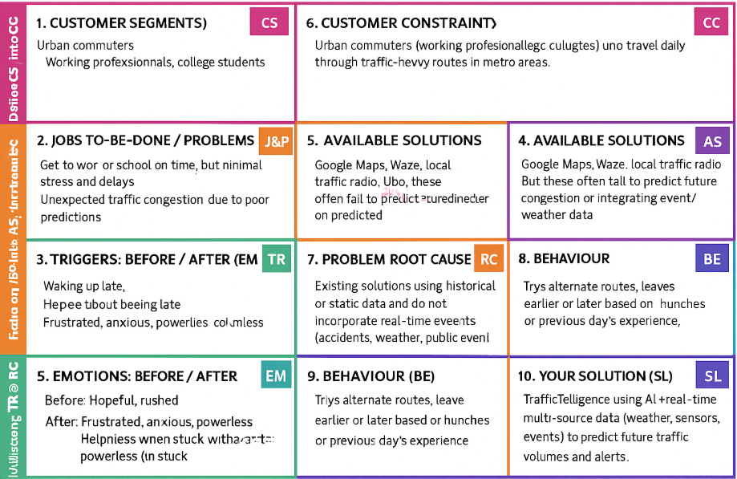

References:

1. <https://www.ideahackers.network/problem-solution-fit-canvas/>
2. <https://medium.com/@epicantus/problem-solution-fit-canvas-aa3dd59cb4fe>